FYP - Automated Data Collecting System for Environment Using UAVs and Smartphones

User Guide

Table of Contents

How to run the system 3

How to save data 4

How to disconnect the UAV 5

How to clear the old mission 5

How to quit the application 6

## How to run the system

1. Boot the Raspberry Pi

2. Connect the Wi-Fi named “Navio” from your raspberry Pi AP

3. run monitor.py on your laptop

python3 monitor.py

4. Press Connection in the navigation bar from the monitor APP

5. Press the Connect button to make connection between the UAV and the notebook

## How to save data

1. Press the Mission button on the Navigation bar

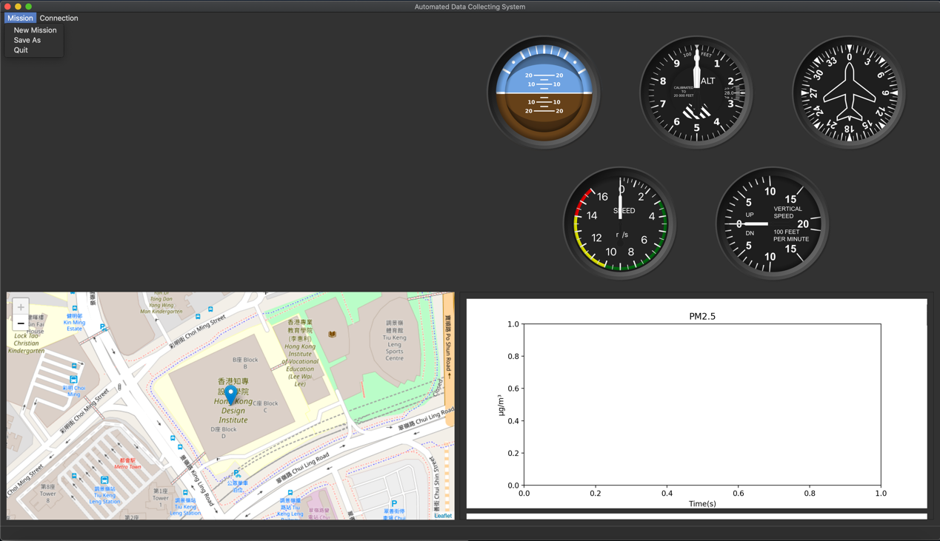

2. Press the Save As button to select the path that you want to save

## How to disconnect the UAV

1. Press the Connection button on the Navigation bar

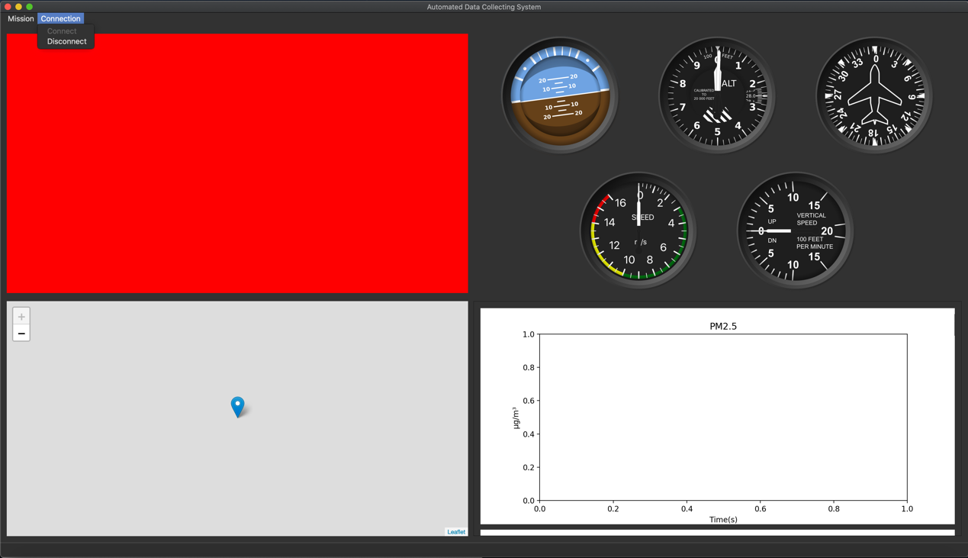

2. Press the Disconnect button to disconnect the UAV

## How to clear the old mission

1. Press the Mission button on the Navigation bar



2. Press the New Mission button to start a new missions

It will clear all the data from previous mission, please save before you start a new mission.

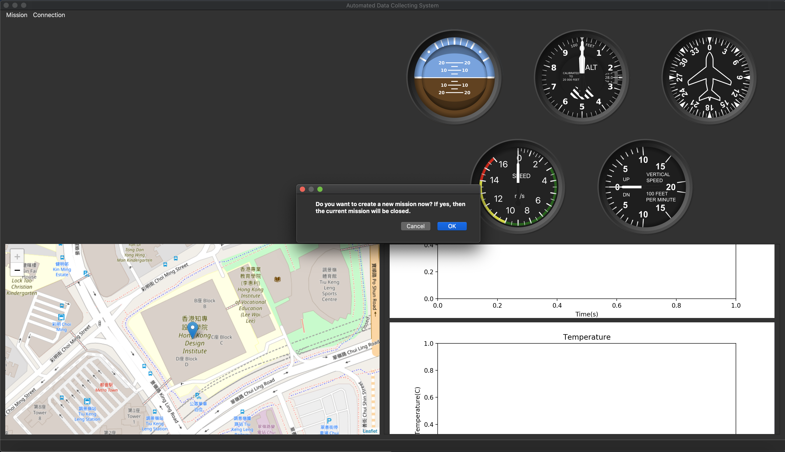

## How to quit the application

1. Press the Mission button on the Navigation bar



2. Press the quit button

## 